BEIJING JIAOTONG UNIVERSITY
GRADUATION PROJECT(THESIS)

Investigating the role of roundabout networks in the formation of Braess-like congestion

School : Beijing Jiaotong University
Major： Traffic and Transportation
Student name : _ Yimin Xu_ _____
Student ID： ______ 18252051____ __
Supervisors： _____Marco Rinaldi____ _
___ Rongsheng Chen____

May 2022

Preface
Regarding the writing of the whole research and thesis, I would like to thank my supervisor Rongsheng Chen at Beijing Jiaotong University and Marco Rinaldi from Delft University of Technology, who are always there to help me whenever I encounter problems and difficulties, answer my questions, without their long-term support and help, it is difficult for me to complete this research in the limited time. Also, thanks for the figure (Figure 3-1) taken from http://www.doczj.com/doc/379975d5ce2f0066f53322ad-7.html.
Yimin Xu
Beijing, 5.2022

Table of Contents
Investigating the role of roundabout networks in the formation of Braess-like congestion 1
Preface 2
Summary 4
1 Introduction 5
1.1 Project motivation 5
1.2 Research objective 5
1.3 Thesis structure 6
2 Literature study 7
2.1 The Research of Braess paradox in the Field of Transportation 7
2.2 Examples of the phenomenon of Braess paradox in the road network 7
2.3 Research on roundabouts 7
2.4 Simulation research on roundabouts 8
2.5 Problems in current research 9
3 Methodology 11
3.1 Reasons for Braess paradox at roundabouts 11
3.2 Introduction of roundabout networks 11
3.3 The occurrence of traffic congestion 13
3.4 Simulation process 14
3.4.1 Simulation tool SUMO 14
3.4.2 Simulation steps 14
4 Results 18
4.1 Sensitivity analysis to explore the occurring conditions of the phenomenon of Braess paradox 20
4.2 Solutions 26
4.2.1 Block some turns 26
4.2.2 Traffic light control 26
5 Conclusions 36
References 37

Summary

With the continuous development of modern cities, the urban road network is also expanding, but it sometimes leads to more traffic congestion in the city, which is the classical Braess paradox. the phenomenon of Braess paradox not only occurs on gridded roads, but also occurs at roundabouts due to their own right-of-way rule, which aggravates traffic congestion in the roundabout network. Therefore, it is of great significance to investigate the role of roundabout networks in the formation of Braess-like congestion. This thesis studied Braess paradox through two different roundabout networks in Beijing, China and Pavia, Italy, using sensitivity analysis to explore the conditions under which the phenomenon of Braess paradox occurs, and obtained the following conclusions: In the case of very low traffic flow, the roundabout network is not congested, so the phenomenon of Braess paradox does not exist in this case. The phenomenon of Braess paradox occurs when the traffic flow rises to a certain level of congestion in the roundabout network, and it continues to intensify with the increase of traffic flow. In addition, this thesis also proposes two solutions to alleviate the traffic congestion caused by the phenomenon of Braess paradox in the roundabout network: blocking some turns and traffic light control. The shortcomings of the whole research and the directions that other researchers can further study under this topic are also discussed.

Keywords Braess paradox, roundabout, traffic congestion

Introduction

Project motivation

In 1968, the German mathematician Braess^{[1]} first discovered that when the distribution of traffic flow in a network determined by a specific topology structure reaches equilibrium, adding a road (Braess link) to the road network might increase the travel time of travellers on the network^{[2]} and the efficiency of the entire network will also be reduced, which is the famous Braess paradox phenomenon. This phenomenon is mainly a result of the fact that the Nash equilibrium point is not necessarily system optimal, that is, everyone wants to optimize individual benefits rather than the benefits of groups.
Analyzed from the perspective of game theory, Braess paradox can be understood as a "prisoner's dilemma". In the game, each competitor hopes to reach their destination in the shortest time, so they do not consider whether their choice will affect others when choosing a route. When a new road segment is added to the road network, it may lead to a change in the optimal path to the destination under the new situation, and when all competitors change their strategies to cope with this change, everyone will also increase the cost due to this new strategy, which will lead to a decrease in the efficiency of the entire system.
The phenomenon of Braess paradox goes against our common sense, and the effect of this paradox disappears under high traffic demand. When the traffic demand is high, people will feel that the traffic on a certain road will be very congested, hence many people will choose other routes to divert traffic, and the traffic conditions of the entire network have been improved instead.

Research objective

Roundabout is a common and special form of road plane crossing in the global road network. Based on factors such as the footprint of the roundabout, the shape and size of the central island, roundabouts can be divided into three categories: regular roundabouts, small roundabouts, and micro roundabouts. Compared with ordinary intersections that use traffic lights to reduce traffic conflict, the characteristic of roundabouts is that by setting up a central island in the center, the intersecting vehicles are driven in the same direction, so as to achieve the purpose of greatly reducing traffic conflict points, thereby improving the driving safety. Therefore, roundabouts are often used for level intersections constructed in China in the early days. In addition, roundabouts have their own unique right-of-way rules: traffic inside the roundabout has a higher right of way than traffic entering into the roundabout. However, the roundabout also has obvious shortcomings: due to the existence of the central island, the roundabout occupies a large area and the space for vehicles to pass is relatively limited, thus, its traffic capacity is greatly restricted. With the rapid growth of the number of motor vehicles in China in recent years, the traffic flow on the road network is also increasing, and the shortcoming of the limited traffic capacity of the roundabout is becoming increasingly prominent, and more traffic congestion has begun to occur at roundabouts. In addition, if the design of the roundabout network is unreasonable, the roundabout is prone to the phenomenon of Braess paradox due to its own right-of-way rules. In the context of the proliferation of vehicles on the urban road network, the phenomenon of Braess paradox can exacerbate traffic congestion on the roundabout network. Therefore, it is of great significance to explore the conditions for the occurrence of the phenomenon of Braess paradox in the roundabout network and propose corresponding solutions for alleviating the traffic congestion of the roundabout network under the phenomenon of Braess paradox.
So far, the roundabout has attracted the research interest of many scholars from all over the world. Many scholars have conducted in-depth research on it in terms of right of way, capacity, delay, level of service, geometric structure, etc. Roundabouts have also been simulated to evaluate their performance, but no research has been done on the phenomenon of Braess paradox on roundabout networks.
The core purpose of this research is to explore whether the right of way at the roundabout can lead to the occurrence of the phenomenon of Braess paradox when the road network topology is determined. Considering the highly detailed modeling methods and computational difficulties, this paper establishes a traffic micro-simulation model for two real roundabout networks, uses sensitivity analysis to explore the conditions under which the phenomenon of Braess paradox occurs, and proposes practical and effective traffic strategies. Through reasonable traffic control, the inefficient and selfish user behaviors in the roundabout network can be transformed into more coordinated and efficient behaviors, and the traffic efficiency of the road network can be maximized, thereby alleviating the traffic congestion caused by the phenomenon of Braess paradox on the roundabout network. At present, many previously built roundabout networks in major cities have obvious phenomenon of Braess paradox due to unreasonable design, which further aggravates the traffic congestion caused by the surge of vehicles on the road network and seriously affects the traffic efficiency of the road network. In this context, this research not only fills the gap in the research on the phenomenon of Braess paradox for the roundabout network, but also provides a new idea for alleviating the traffic congestion in the existing roundabout networks.

Thesis structure

This thesis is organised in four parts: literature study, methodology, results and conclusions. The second chapter, literature study, includes introductions to some previous research and simulations of roundabouts and problems in current research. The third chapter, methodology, introduces the reasons for the occurrence of Braess paradox in the roundabout network, the occurrence of the traffic congestion, and the simulation process in this research. The simulation process introduces the software used in this simulation and detailed simulation steps. The fourth chapter, results, includes two parts: sensitivity analysis to explore the conditions for the occurrence of the phenomenon of Braess paradox and solutions to alleviate the traffic congestion caused by Braess paradox in the roundabout networks. The fifth chapter, conclusions, is to summarize the conditions for the occurrence of the phenomenon of Braess paradox in the roundabout network, and the effect, advantages and disadvantages of alleviating the traffic congestion caused by Braess paradox, and to explain and illustrate the problems existing in this research and the directions that other researchers can further study under this topic.
In addition, the technology roadmap of this research is shown in Figure 1-1.

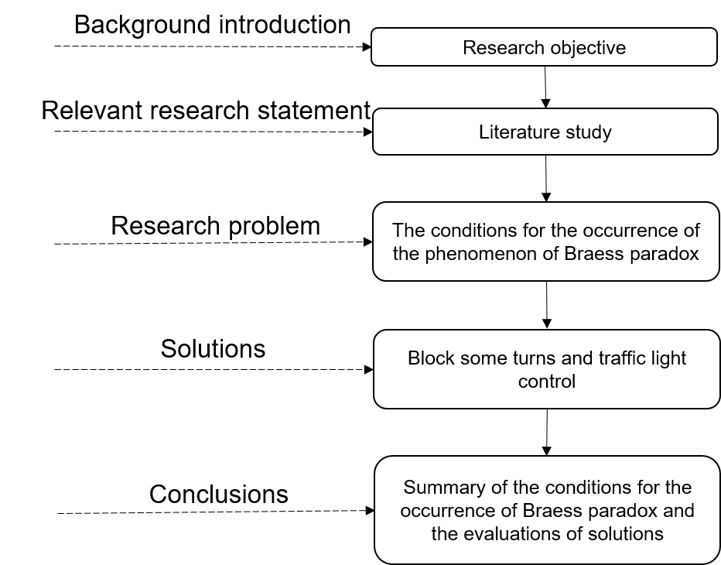
Figure 1-1 Research Technology Roadmap

Literature study

The Research of Braess paradox in the Field of Transportation

So far, many scholars have carried out research on Braess paradox in the field of transportation in terms of generation conditions, generation possibilities, route recommendation, and network structure optimization.
Eric et al.^{[3]} studied the conditions for the occurrence of the phenomenon of Braess paradox in 1997, and found that the occurrence of Braess paradox in the traffic network is related to the cost function and the traffic flow. For a road network with a given set of cost functions, the phenomenon of Braess paradox occurs only when the traffic flow is within a certain range (the range depends on the cost function parameters).
In 1983, Steinberg and Zangwill^{[4]} considered a linearly separable cost function, and under reasonable assumptions, provided the sufficient and necessary conditions for the occurrence of Braess paradox in the general traffic network. They concluded that the probability of Braess paradox occurring is not much different from the probability that it does not occur.
In 2005, Bazzan and Klügl^{[5]} studied the effect of alleviating the phenomenon of Braess paradox on the road network by providing route recommendations to drivers. In their research, they presented calibrations and results of a generalized cost function for an abstract model suitable for any number of driver situations and a micro-simulation that did not require a cost function, respectively, and finally concluded that providing route recommendations to travellers is effective in mitigating the phenomenon of Braess paradox on road networks.
The research of Roughgarden^{[6]} in 2006 showed that the performance improvement effect obtained by removing the Braess redundant link in a large network can be arbitrarily large, but the difficulty of the optimization of the network structure will increase with the size of the network.
Youn^{[7]} pointed out in a 2008 research that travellers all aspire for the lowest personal travel cost (time), which would make the road system unable to reach the optimal state, and thus increase nearly 30% of the travel cost (time).
In 2014, Bagloee et al.^{[8]} used the road network data in Winnipeg, Canada to construct a genetic algorithm-based heuristic method to solve the difficult Braess Paradox Detection (BPD) problem. In 2015, Sun et al.^{[9]} predicted the traffic flow distribution in San Francisco's road network based on geographic information system and daily commuting OD matrix data, and studied Braess paradox in a large-scale road network, using a genetic algorithm to search for inefficient links.
Hwang and Cho^{[10]} studied the classic Braess problem in 2016. They derived a generalized inverse formula using the change in equilibrium cost after link addition without assuming a unique path flow solution, and showed that there was at least one OD pair directly connected through the newly added link. This derivation extended the theory derived from the research of the classic Braess paradox to the cases where multiple routes are arbitrarily generated after adding a new road to the road network, and can be used to predict the occurrence of the phenomenon of Braess paradox in more general transportation networks.

Examples of the phenomenon of Braess paradox in the road network

So far, although it may be challenging to precisely control the demand and measure the driving time (cost) of the driver on the actual road system, there have been several examples of the inverse effect of Braess paradox, that is, after Braess link of the network was removed, the travel time of vehicles in the whole road network was improved.
For example, Kolata^{[11]} once wrote in the "New York Times" that in 1990, New York City closed its ever-congested 42nd Street to provide a venue for the “Earth Day” parade. But unexpectedly, traffic conditions in New York improved that day.
In 1999, one of the three main traffic tunnels in Seoul, the capital of South Korea, was closed for maintenance. Surprisingly, this action did not cause chaos and traffic jams in the surrounding area, but improved the situation of serious congestion at that time.^{[12]}
In 2009, in a project in New York City, a part of Broadway in central Manhattan was converted into a pedestrian plaza where vehicles were blocked and the road traffic also improved to a certain extent.^{[13]}

Research on roundabouts

With the increase of vehicles in urban areas, the urban transportation network is also becoming more congested, causing much inconvenience to pedestrians, especially at intersections in major cities where delays and poor service levels often occur. At the same time, constructing unsignalized roundabouts is believed to significantly reduce delays and is often cited by urban transport planners as one of the possible solutions to traffic congestion at existing signalized intersections. Therefore, many researchers have studied, the priority, capacity, delay, service level, geometry of roundabouts, etc.
In studying the priority of roundabout, the research of Troutheck^{[14]} in 1999 found that there is no absolute priority between the vehicles entering the roundabout and the flow in the roundabout and the latter only has a limited priority. This limited priority has a significant impact on the capacity of the roundabout. In 2003, Tanyel^{[15]} came to a conclusion similar to Troutheck when he observed the traffic flow at a roundabout in Turkey, where traffic flow shares the right of way with the vehicles inside the roundabout when entering the roundabout.
In studying the traffic capacity of roundabouts, Ren et al.^{[16]} analyzed the traffic flow of conventional roundabouts in Beijing in 2001, and proposed a simplified model of traffic flow in the interweaving area within the roundabout. He then used the fleet analysis method to determine the capacity of the weaving area, and finally used the linear optimal method to calculate the capacity of the entire roundabout. In 2002, Pollatschek et al.^{[17]} proposed a micro-decision-making model for estimating the capacity of the roundabout for the driver's gap acceptance behavior while waiting at unsignalized roundabouts on secondary roads. Unlike the traditional macro critical gap approach, this model took personal preferences into account by defining the individual critical gap. Zhang et al.^{[18]} took the Jiangcheng Square roundabout in Jilin City as an example in 2003, and they established a model for the capacity of a complex roundabout by using mathematical statistics based on the actual observation data to provide a theoretical approach for the research of the capacity of complex roundabouts. In 2004, Jin et al.^{[19]} conducted a simulation to study the capacity of roundabouts, and analyzed the key parameters affecting the capacity from a microscopic perspective. Yap et al.^{[20]} in 2013 modeled the capacity of roundabouts and used three main approaches on which such models are built: full experience, distance acceptance, and simulation. Their results showed that each method cannot fully explain the complex behaviours and physical processes in roundabout entrances due to the limitations of each method, and due to the differences in driving habits and behaviours of drivers in different countries, the capacity of the roundabout predicted by these models also have great deviations. Although local calibration can be a kind of solution, it is often limited by factors such as data availability. In 2018, Chen^{[21]} recalculated the coefficients of each roundabout capacity model in HCM (6th edition) and HCM (2010) based on the same gap acceptance theory proposed in HCM, and used video data from a two-lane roundabout in Chiffield to calibrate the model, and finally developed two new two-lane variants of the roundabout capacity model and compared them with the exponential regression models fitted with actual measurements of flow in Chiffield to evaluate the accuracy of two models.
In studying delays at roundabouts, Burov et al.^{[22]} proposed an algorithm to detect the occurrence of Braess paradox in road networks based on a convex optimization problem using Beckmann potential to optimize road segments and queues in 2021. The algorithm is able to find routes (Braess routes) that lead to the phenomenon of Braess paradox, re-plan new routes with reduced delays for the user, and recommends the user to delete such routes from the navigation system so that the relevant road segments can better serve other travellers. Finally, they verified the feasibility of the algorithm for improving the traffic efficiency of the road network through simulation.
In studying the level of service of roundabouts, Bo et al.^{[23]} studied the capacity and level of service of roundabouts in 2002. On the basis of establishing a theoretical model of the capacity, they elaborated the method of calculating the capacity of roundabouts and calculated the capacity of three typical roundabouts.
In studying the geometry of roundabouts, Arndt and Troutbeck^{[24]} in 1998 studied the relationship between the geometry and accident rates of one hundred roundabouts in Queensland, Australia. They performed regression analyses for each accident category and concluded that roundabout safety can be increased by limiting the driver's expected speed difference, limiting approach speed, and minimizing the relative speed between merging traffic and traffic within the roundabout through continuous geometrical design.

Simulation research on roundabouts

The operating speed of a roundabout is affected by many factors, and its performance can affect the urban transportation system in terms of operation, safety, etc. Therefore, with the widespread use of roundabouts, suitable analytical techniques need to be used to evaluate roundabouts. Traffic management and control at roundabouts can be performed using a road traffic micro-simulation model where calibration is provided. At present, traffic simulation has been used to study the performance of signalized and unsignalized roundabouts in terms of capacity, level of service, etc.
In order to explore the traffic impact of roundabouts, Bared et al.^{[25]} used VISSIM traffic simulation software to model urban single-lane and two-lane roundabouts in 2005. The results were compared with the real data collected from the United States, and it was found that the VISSIM simulation results are closer to the real data than the results of the RODEL model and the aaSIDRA model.
In 2007, Vaiana et al.^{[26]} conducted simulation experiments on a large number of roundabouts under different geometric structures (inscribed circle radius, circular road, center island, etc.), traffic flow characteristics (density, distribution, speed of entry, etc.) to assess the level of service at the roundabout by using an improved vehicle flow simulation software.
Yin and Qiu^{[27]} used the macro traffic analysis software SIDRA and the micro simulation software VISSIM in 2011 to study and analyze a two-lane roundabout at the intersection of two rural arterial roads in Alberta, Canada, to compare the two traffic Analyze tools and assess the impact of different factors on roundabout performance.
In 2012, Zhao Hailong et al.^{[28]} established simulation models for a roundabout and an intersection based on the four-phase control of intersections and two-step left-turn control theory, and conducted simulation experiments under different traffic volumes and left-turn ratios to study the relationship between traffic flow and capacity of the roundabout and the intersection.
Arroju et al.^{[29]} used VISSIM in 2015 to estimate the capacity of roundabouts. In their research, they indicated that VISSIM outperforms other models in estimating capacity since it takes into account roundabout geometry and driver driving habits, and can accurately simulate different traffic situations. The simulation results of the research also showed that the capacity obtained by VISSIM is very close to the actual one.
Małecki and Wątróbski^{[30]} constructed a cellular automata-based traffic simulation model for roundabouts in 2017. The model took into account roundabouts of various sizes and various types of vehicles, and proposed a vehicle braking model that adjusts to vehicle type and weather conditions. At the same time, they also analyzed the traffic options at the entrance and exit of the roundabout, and concluded through the simulation results that the roundabout had a lot of scope for improvement in terms of capacity.
Chen^{[21]} used the traffic simulation software AIMSUN in 2018 to conduct simulation research on a two-lane roundabout in Richfield, Minnesota, USA. This research used sensitivity analysis to explore the effect of different simulation parameters, and selected some parameters (initial safety margin, visibility along main stream, reaction time at stop, and max acceleration) to calibrate the driver's gap acceptance behaviour in the model, and compared it with the roundabout capacity model HCM (6th edition). He finally obtained the conclusion that if the calibration model established by AIMSUN can produce the same critical headway and follow-up headway as the roundabout capacity model in HCM (6th edition), it can also obtain the same roundabout capacity, which proved that the traffic simulation software AIMSUN can build a roundabout model with realistic capacity.
Gallelli and Vaiana^{[31]} in 2019 compared a “virtual” roundabout with a spiral ring lane to a multi-lane roundabout in the Italian city of Cosenza, by using VISSIM to perform a micro-simulation of traffic conflicts. They also compared and evaluated the performance and safety impacts of the two roundabouts based on the spatial distribution of potential conflicts derived from the SSAM safety assessment model, and concluded that a "virtual" roundabout with a spiral ring has significantly fewer potential collisions than a traditional multi-lane roundabout.
In 2020, Owais et al.^{[32]} studied the level of service of two roundabouts in the cities of Jeddah and Medina over time and their parallel solutions for signalized intersections to determine the best time to convert an existing roundabout to a signalized intersection. They used the simulation tools Sidra and Synchro to synthesize demand scenarios that represent normal increases in traffic flow over the past few years, found two underperforming years at intersections, and evaluated the impact of increased left-turn traffic on intersections for each solution type.

Problems in current research

At present, most of the traffic research on Braess paradox only starts from the level of traffic theoretical knowledge, and does not comprehensively consider various complex factors such as people and the environment. If strong measures (such as separating traffic lanes from sidewalks with fences, extensive use of simple one-way streets, road closures, etc.) are used to improve the traffic conditions and increase the capacity of the road network, it may violate the original intention of building roads to bring convenience to people, because the construction of urban roads is to meet people's various travel needs. The above similar measures are essentially physical traffic control behaviors, not from the perspective of traffic light control. And also the problem of urban traffic congestion is not considered and solved at the root cause. Therefore, when the Braess paradox phenomenon occurs in the urban road networks, urban traffic planners cannot simply consider closing roads to solve the problem of severe congestion, but should comprehensively consider various factors and control the traffic flow through reasonable means, so as to alleviate the traffic congestion.
In addition, plenty of current traffic research on Braess paradox uses theoretical models, which cannot well describe the states of vehicles on the real road network, and cannot take into account the microscopic behavior of vehicles such as the interaction between vehicles. It is also difficult to establish a theoretical model for some complex situations. Simulation research can solve the above problems very well. It can take into account the microscopic behaviors of vehicles, and solve some complex problems that are difficult to solve by analytical methods, and optimize through trial and error. In addition, simulation research can also tentatively explore the problems existing in the road network, and confirm which measures are effective in solving practical problems. And compared with actual experiments, simulation research can obtain results in a shorter time with a lower cost.

Methodology

Reasons for Braess paradox at roundabouts

When the vehicles from the same origin and to the same destination have multiple paths entering into the roundabout in their routes and the rondabout network is congested, Braess paradox can occur in the roundabout network, which is mainly caused by the unique right-of-way rule of roundabout.

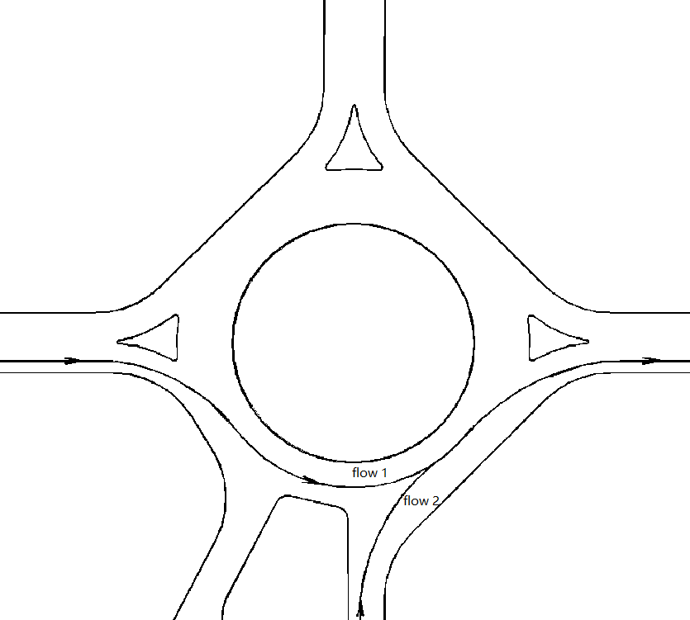
Figure 3-1 Traffic flow at the roundabout

As shown in Figure 3-1, the traffic flow in the roundabout (flow 1) has a higher right-of-way than the traffic flow entering into the roundabout (flow 2). When flow 1 and flow 2 conflict in the entrance of roundabout, the latter needs to stop and wait for the former to pass first. Therefore, the vehicles coming from the same direction towards the roundabout tend to choose the route that can enter the upstream of the roundabout, thus giving them the upper hand in the traffic game. Overall, this can cause the traffic efficiency of the entire roundabout network to decrease, resulting in the phenomenon of Braess paradox.

Introduction of roundabout networks

In this research, two roundabouts from Beijing in China and Pavia in Italy respectively, were selected for research. They both have multiple paths leading to the roundabout. The actual structures of two roundabout networks are shown in Figure 3-2 and Figure 3-3.

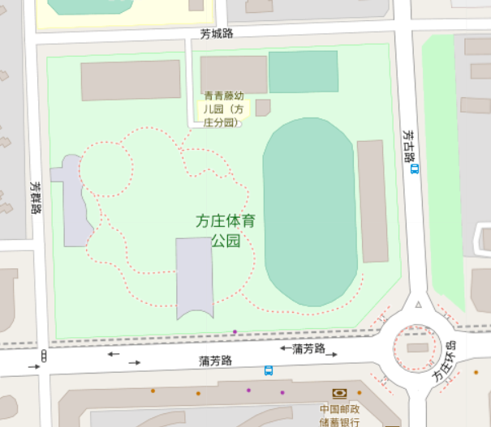
Figure 3-2 The actual structure of Beijing roundabout network

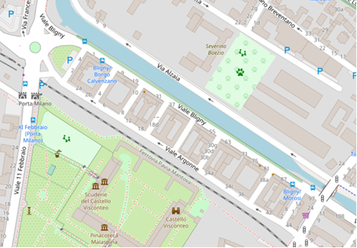
Figure 3-3 The actual structure of Pavia roundabout network

The occurrence of traffic congestion

In this research, the origin, destination, and routes of the traffic flow for Beijing roundabout network and Pavia roundabout network are shown respectively in Figure 3-4 and Figure 3-5. And this research makes traffic congestion occur on the research roundabout network mainly by adjusting the traffic flow.

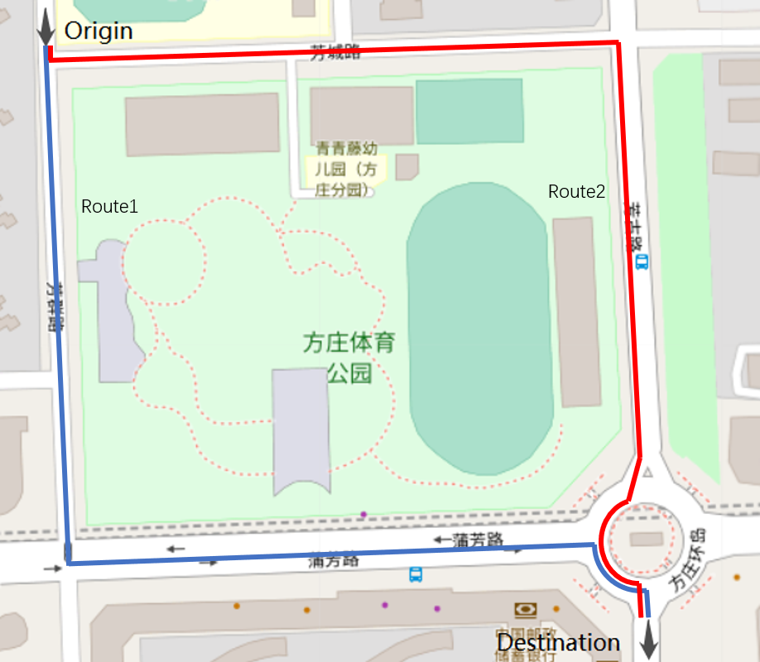
Figure 3-4 Origin and destination of Beijing roundabout network and its route map

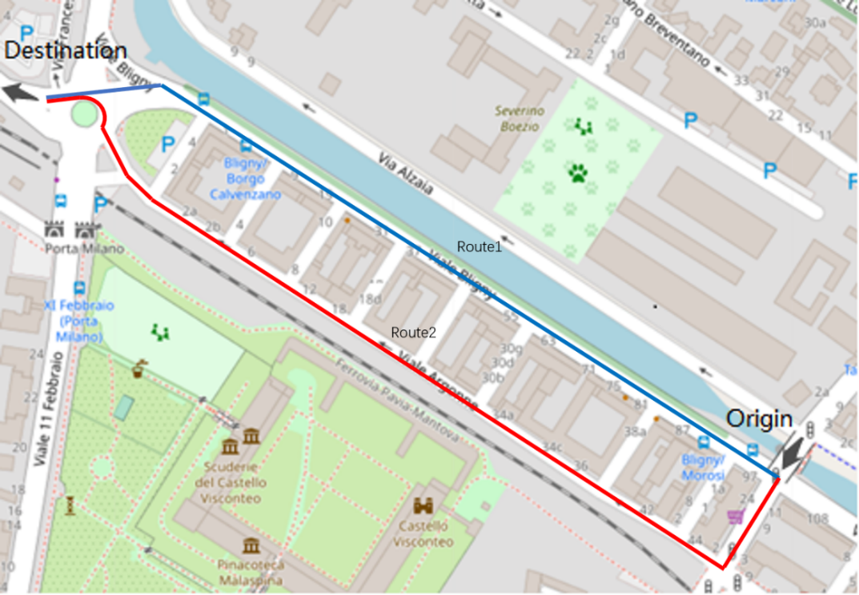
Figure 3-5 Origin and destination of Pavia roundabout network and its route map

Simulation process

Simulation tool SUMO

The simulation tool used in this research is SUMO, whose full name is Simulation of Urban Mobility. It is a free, open, multi-modal, micro-traffic simulation software that can control each vehicle individually and is very suitable for developing traffic control models. SUMO has many advantages and can model multiple traffic modes including road vehicles, public transport, and pedestrians. In addition, SUMO contains a large number of supporting tools to automate the core tasks of creating, executing and evaluating traffic simulations, such as network import, route calculation, visualization, and emission calculation. SUMO can be enhanced with custom models and provides various APIs for customizing the setup and data extraction of the simulation process. SUMO can easily extract vehicle and road information, and has many car-following models and lane-changing models (such as IDM, ACC, CACC car-following models). Compared with VISSIM, SUMO can use TraCI (Traffic Control Interface) to develop models through Python language, and VISUM, Vissim, Shapefiles, OSM, RoboCup, MATsim, OpenDRIVE, and XML-Descriptions can be imported.
At present, SUMO has been applied in many traffic fields, including evaluating the performance of traffic lights, studying vehicle routing, providing traffic forecasting, evaluating the performance of global system for mobile communication (GSM) based traffic monitoring, providing realistic vehicle tracking as well as evaluating applications in online loops using network simulators, artificial intelligence training for traffic light programs, simulating traffic impacts of autonomous vehicles, cooperating with other simulation software, simulating and validating the functions of autonomous driving, simulating railway traffic for artificial intelligence-based vehicle scheduling, conducting traffic safety and risk analysis, calculating traffic noise and pollutant emissions, etc.
The tools in SUMO used in this research are as follows:
(1) od2trips: The input information required by od2trips is the O/D matrix and the traffic assignment zones. od2trips can map the traffic flow defined by the starting point and the target area to the road network, and split them into individual vehicle trips.
(2) netedit: netedit is a visual network editor that can be used to create a network from scratch or modify an existing network and test various properties of the road network. netedit can also be used to define and edit infrastructure, vehicles, people, routes, shape data, etc.
(3) sumo-gui: sumo-gui can simulate and display the scenarios defined in SUMO.
(4) OSMWebWizard: Based on the selection of the Openstreetmap excerpt, it can configure random traffic requirements, and can run and visualize the scene in sumo-gui.
(5) duaIterate: duaIterate requires at least two files (SUMO road network file and vehicle trip information file) as script input, which can help perform the calculation of Dynamic User Assignment (DUA). It works by running simulations alternately to observe the travel times of vehicles in the road network, and then assigning alternative routes to certain vehicles based on the travel times of the vehicles. If the user defines the number of iterations, duaIterate will repeat this operation according to the defined number of iterations. If the user does not define the number of iterations, duaIterate will repeat this operation according to the default number of iterations of the system. After duaIterate performs the calculation of dynamic user allocation (DUA), the road network does not necessarily reach the user equilibrium (UE) state, but the user can increase the probability of convergence to equilibrium by increasing the number of iterations.

Simulation steps

1 Use SUMO's osmWebWizard to collect and export the structure of the roundabout network from Openstreetmap.
2 Use SUMO's tool netedit to modify the imported road network structure, and adjust parameters of the road network (such as speed limit, road priorities, crossing rules, etc.) according to the actual situation and turns(after inquiry, Pufang Road in Beijing roundabout network is a class 2 road, other roads in Beijing roundabout network and all roads in Pavia roundabout network are class 3 roads, so this simulation research sets the speed limit of Pufang Road in Beijing roundabout network to 80km/h, and sets the speed limit of other roads in Beijing roundabout network and all roads in Pavia roundabout network to 50km/h; the traffic rule of all intersections is set to allow vehicles to enter the intersection when the road ahead is congested to prevent too long vertical queues in the case of high traffic flow). The obtained structure of simulated Beijing roundabout network and the obtained structure of simulated Pavia roundabout network are shown in Figure 3-6 and Figure 3-7 respectively.
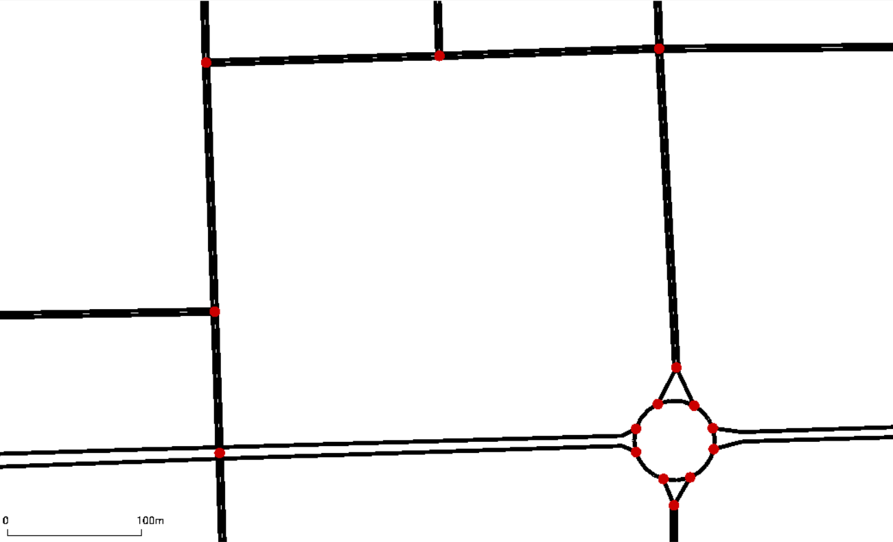
Figure 3-6 Structure of simulated Beijing roundabout network

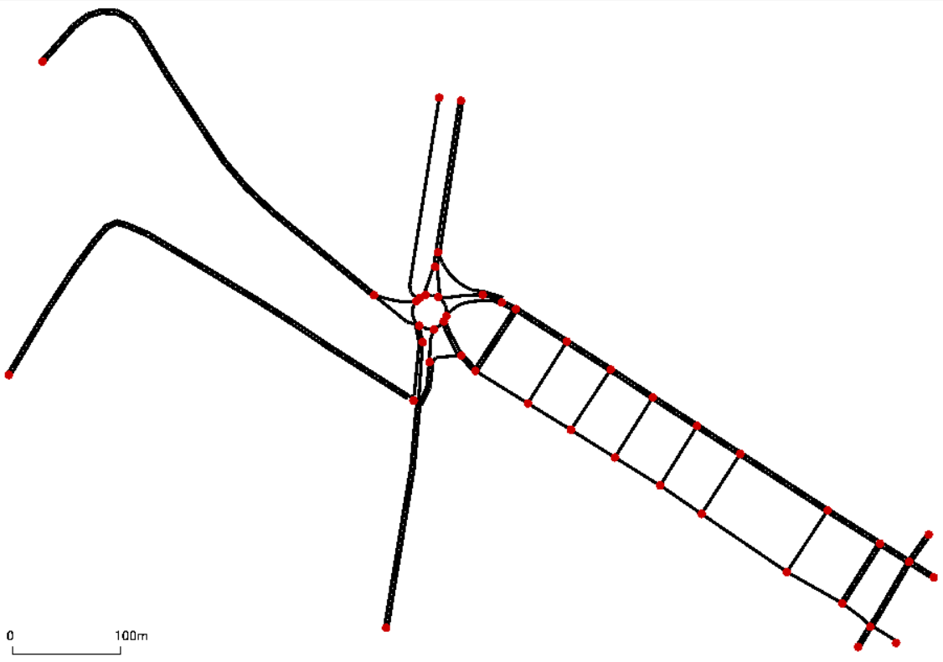
Figure 3-7 Structure of simulated Pavia roundabout network

3 Use the netedit to create traffic assignment zones for the roundabout network (ie, the input area and output area of the traffic flow in the road network), and generate the corresponding traffic assignment zone information file. The traffic assignment zones created in Beijing roundabout network and the traffic assignment zones created in Pavia roundabout network are shown in Figure 3-8 and Figure 3-9, respectively.
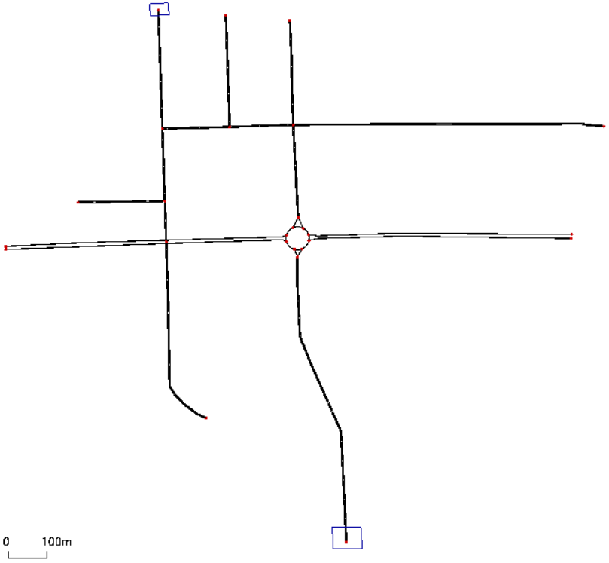
Figure 3-8 Traffic assignment zones of Beijing roundabout network

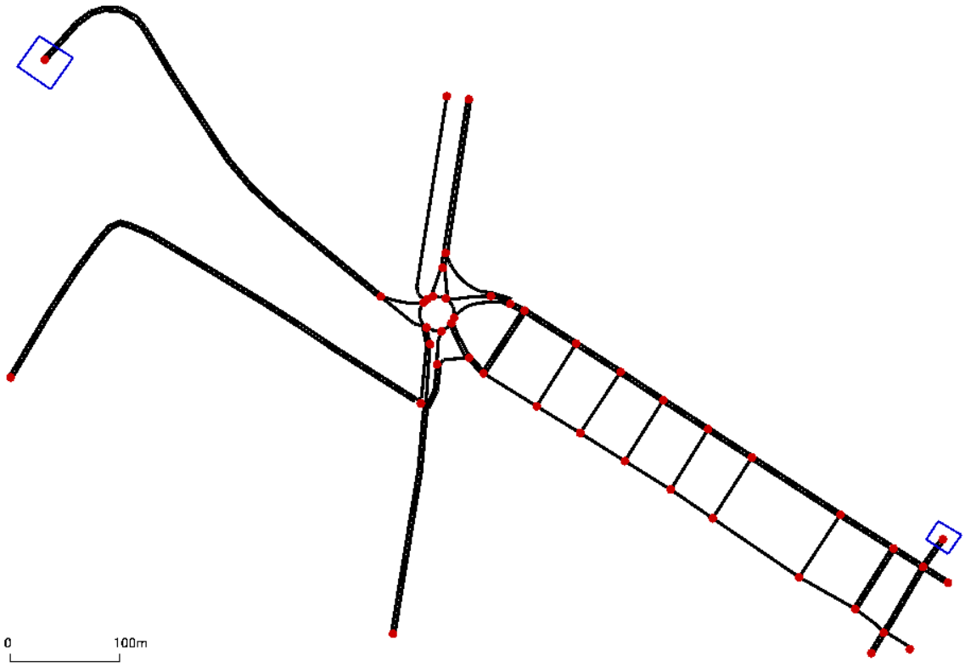
Figure 3-9 Traffic assignment zones of Pavia roundabout network

4 Write python code for sensitivity analysis to explore the occurring conditions of the phenomenon of Braess paradox in the roundabout network. The specific steps of sensitivity analysis are as follows:
- Create the corresponding traffic flow information file under different traffic flow (traffic flow equally increases).
- Use SUMO’s tool od2trips to generate the corresponding vehicle trip information files by using the corresponding traffic assignment zone information file and different traffic flow information files.
- Use SUMO's tool dualterate to perform iterative calculations of Dynamic User Equilibrium (DUE) by using the corresponding road network file and vehicle trip information files (in order to balance the iterative calculation time and iterative effect, this research sets the iteration limit to 20).
- Collect the travel time of each vehicle to obtain the total travel time of vehicles of the target OD pair of the road network in the roundabout network under each traffic flow, and judge whether the phenomenon of Braess paradox occurs by comparing the total travel time of vehicles of the target OD pair before and after blocking some turns.
5 Design traffic lights to alleviate the traffic congestion caused by the phenomenon of Braess paradox, and obtain the relatively optimal timing strategy of traffic lights through sensitivity analysis.
The simulation flow of this study is shown in Figure 3-10.

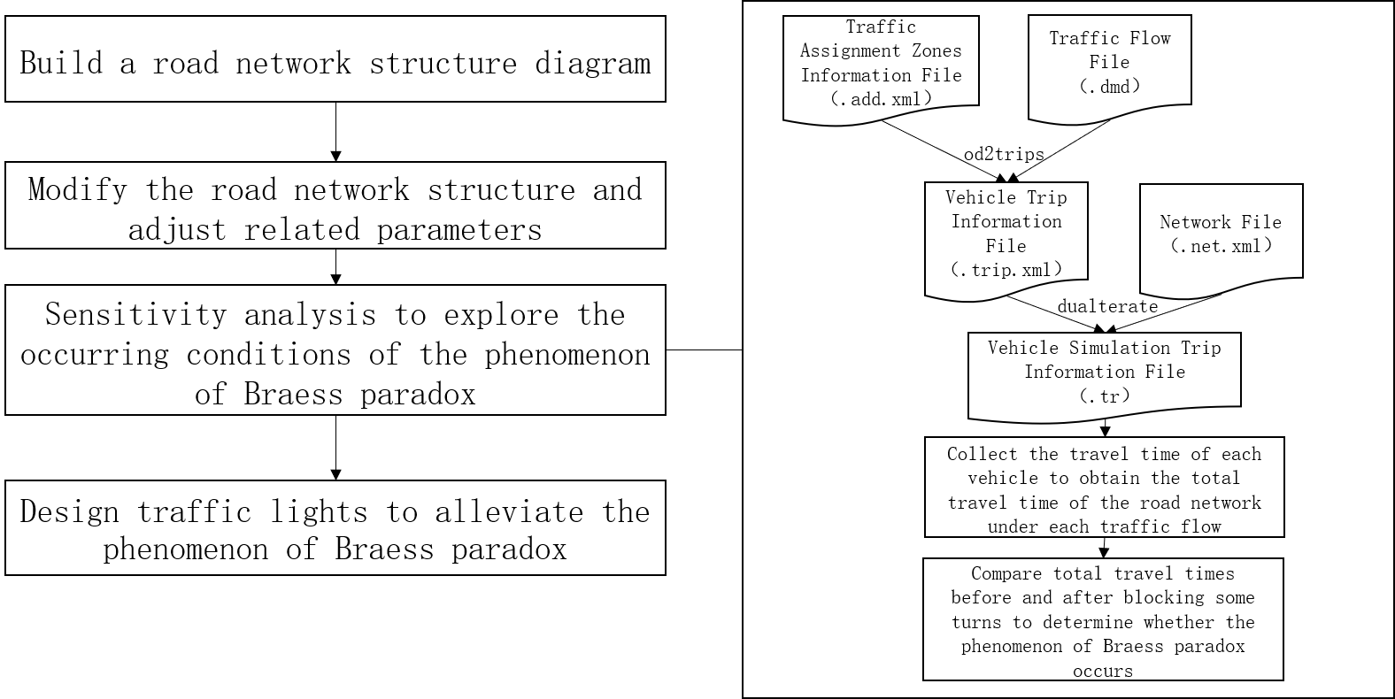
Figure 3-10 Simulation flow

In this research, the calculation formula of the total travel time of vehicles of the target OD pair in the roundabout network is as follows:
In the formula, T represents the total travel time of vehicles of the target OD pair in the roundabout network, t_{i} represents the travel time of the i-th vehicle in the target OD pair in the roundabout network, and n represents the traffic flow of the target OD pair in the roundabout network. In addition, in this thesis, T₁, T₂ and T₃ are used to denote the total travel time of vehicles of the target OD pair in the roundabout network under three conditions: before blocking some turns, after blocking some turns, and through traffic light control.

Results

This research explored the occurring conditions of the phenomenon of Braess paradox in Beijing roundabout network and in Pavia roundabout network in two cases: before blocking some turns (vehicles can choose to enter into the roundabout via either route 1 or route 2 (Braess route)) and after blocking some turns (block all left-turns in the intersections on route 1 before entering into the roundabout, that is, vehicles are only allowed to choose route 1 to enter into the roundabout, and vehicles are not allowed to choose route 2 to enter into the roundabout), as shown in Figure 4-1, Figure 4-2, Figure 4-3 and Figure 4-4. By comparing the total travel time of vehicles of the target OD pair in the roundabout network under the two conditions, it is judged whether the phenomenon of Braess paradox occurs. And sensitivity analysis is used to explore the conditions for the phenomenon of Braess paradox to occur. In addition, the research also tests two solutions (blocking some turns and through traffic light control) that can alleviate the phenomenon of Braess paradox in two roundabout networks.


Figure 4-1 Routes of traffic flow before blocking some turns in Beijing roundabout network

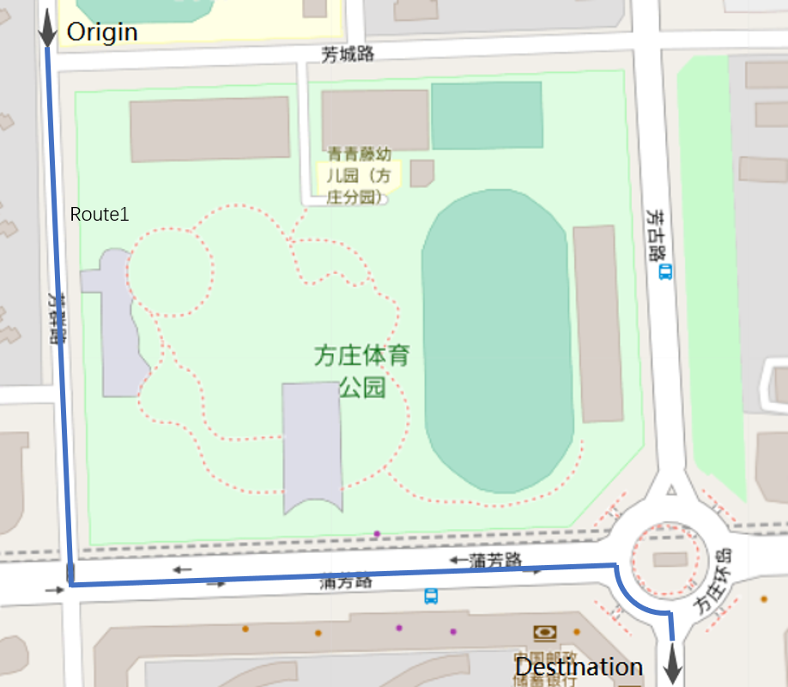
Figure 4-2 Route of traffic flow after blocking some turns in Beijing roundabout network

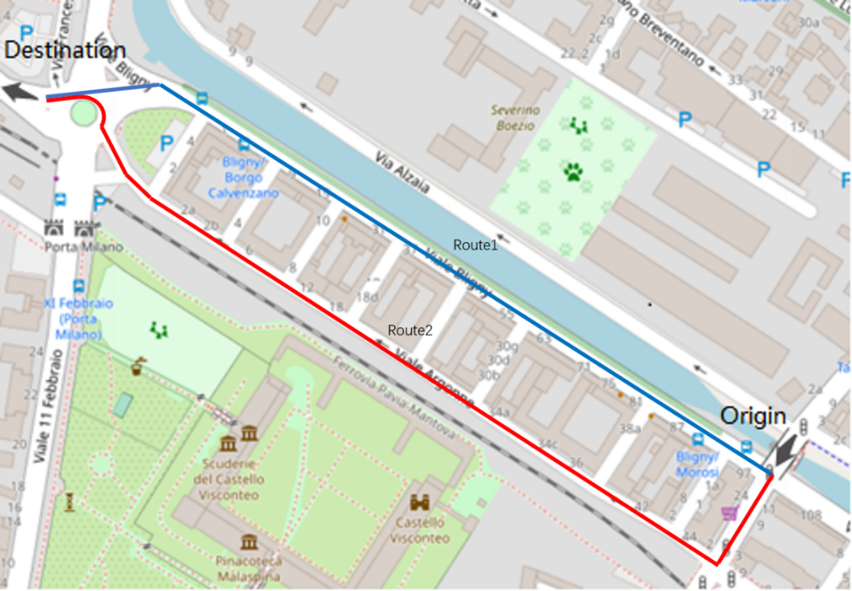
Figure 4-3 Routes of traffic flow before blocking some turns in Pavia roundabout network

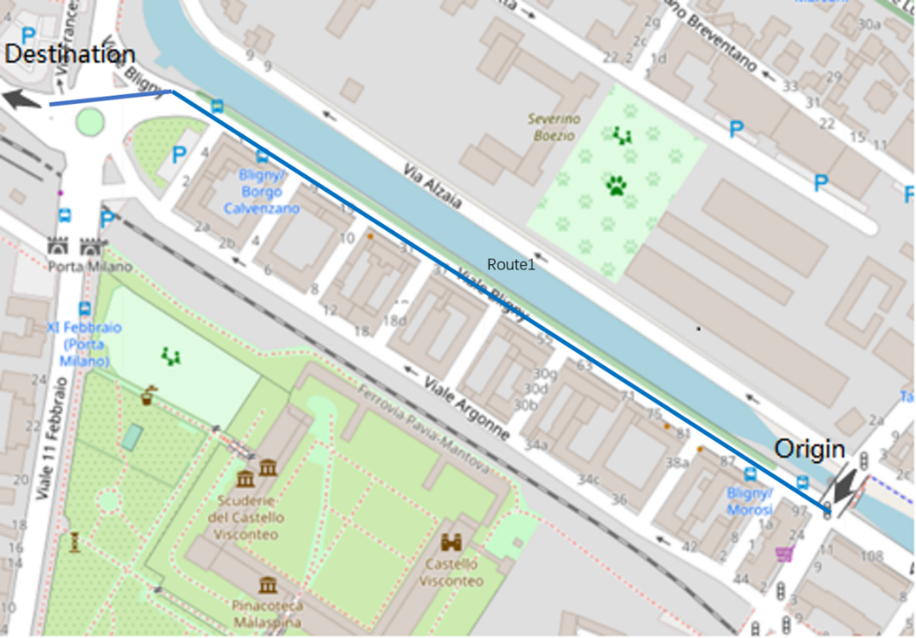
Figure 4-4 Route of traffic flow after blocking some turns in Pavia roundabout network

Sensitivity analysis to explore the occurring conditions of the phenomenon of Braess paradox

In order to explore the conditions for the occurrence of the phenomenon of Braess paradox, this research uses the method of blocking some turns to compare the changes in travel time before and after blocking some turns in two roundabout networks when the traffic flow changes. The experimental results are shown in Figure 4-5 and Figure 4-6 where the horizontal axis represents the traffic flow of the target OD pair in the roundabout network, and the vertical axis represents the total travel time of all vehicles of the target OD pair in the roundabout network. In addition, this research starts the simulation from the situation that the traffic flow of the target OD pair in the roundabout network is 100veh/h (vehicles/hour), increments by 100veh/h each time, to the situation that the traffic flow of the target OD pair in the roundabout network is 3500veh/h (considering the limited actual capacity of the roundabout, it is not meaningful to simulate the situations after 3500veh/h).

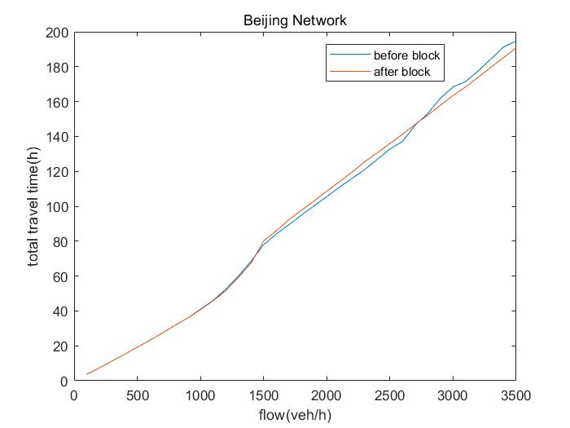
Figure 4-5 The relationship between travel time and traffic flow in Beijing roundabout network before and after blocking some turns

It can be seen from Figure 4-5 that for Beijing roundabout network, when the traffic flow is lower than 1500veh/h, the similarity of the two curves is relatively high, indicating the impact of blocking some turns on Beijing roundabout network is very small, and it can be considered that the phenomenon of Braess paradox does not occur. When the traffic flow is 1500-2700veh/h, the total travel time of vehicles of the target OD pair after blocking some turns T₂ is greater than the total travel time of vehicles of the target OD pair before blocking some turns T₁. When the traffic flow is higher than 2700veh/h, the total travel time of vehicles of the target OD pair after blocking some turns T₂ is smaller than the total travel time of vehicles of the target OD pair before blocking some turns T₁, thus suggesting the occurrence of the phenomenon of Braess paradox, and that blocking some turns can alleviate the congestion caused by the phenomenon of Braess paradox and improve the traffic efficiency of Beijing roundabout network.

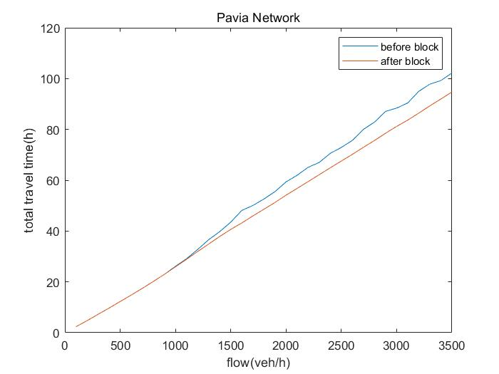
Figure 4-6 The relationship between travel time and traffic flow in Pavia roundabout network before and after blocking some turns

It can be seen from Figure 4-6 that in Pavia roundabout network, when the flow rate is not higher than 1000veh/h, the similarity of the two curves is high, indicating the impact of blocking some turns on Pavia roundabout network is small and it can be considered that the Pavia roundabout does not have the phenomenon of Braess paradox. When the traffic flow is higher than 1000veh/h, the total travel time of vehicles of the target OD pair after blocking some turns T₂ is smaller than the total travel time of vehicles of the target OD pair before blocking some turns T₁, also suggesting the occurrence of the phenomenon of Braess paradox and that blocking some turns can alleviate the congestion caused by the phenomenon of Braess paradox and improve the traffic efficiency of Pavia roundabout network.

Through the research on the phenomenon of Braess paradox of the above two roundabouts, it can be found that for the roundabout network, the phenomenon of Braess paradox does not occur in the case of low traffic flow, but when the traffic flow reaches a certain level, the phenomenon of Braess paradox will occur, and it will continue to intensify with the increase of traffic flow. In addition, under the traffic flow when the phenomenon of Braess paradox occurs, it can be observed that most vehicles in the roundabout network choose to enter into the upstream of the roundabout from route 2 (Braess route), and there is an obvious queuing phenomenon for the vehicles choosing route1 to enter into the roundabout.

In addition, this research also conducted a more detailed analysis of the route selection probability and travel time of each vehicle in Pavia roundabout network when the traffic flow was 2000veh/h, and plotted the curves of the relationship between the probability of selection of route and the departure time of each vehicle in Pavia roundabout network, and the relationship between travel time and arrival time of the vehicle in Pavia roundabout network, as shown in Figure 4-7 and Figure 4-8 respectively. Between them, the horizontal axis of the relationship between the probability of selection of route and the departure time of each vehicle in Pavia roundabout network represents the departure time of each vehicle in Pavia roundabout network, and its vertical axis represents the probability of the vehicle selecting a route in Pavia roundabout network. The horizontal axis of the relationship between travel time and arrival time of the vehicle in Pavia roundabout network represents the arrival time of the vehicle in Pavia roundabout network, and its vertical axis represents the travel time of the vehicle in Pavia roundabout network. However, due to the fluctuation of the travel time of a single vehicle in the original data obtained by the simulation, the plot of the curves of the relationship between travel time and arrival time of the vehicle in Pavia roundabout network is relatively noisy. With certain processing, the average travel time of vehicles arriving every 5 minutes obtained from the processing is used to plot the curves of the relationship between the average travel time of vehicles per 5 minutes and the arrival time of vehicles in Pavia roundabout network to achieve the effect of denoising, as shown in Figure 4-9 shown. In this figure, the relationship between the average travel time of vehicles per 5 minutes and the arrival time of vehicles in Pavia roundabout network is represented by the horizontal axis representing the arrival time of vehicles, and the vertical axis representing the average travel time of vehicles arriving every 5 minutes.

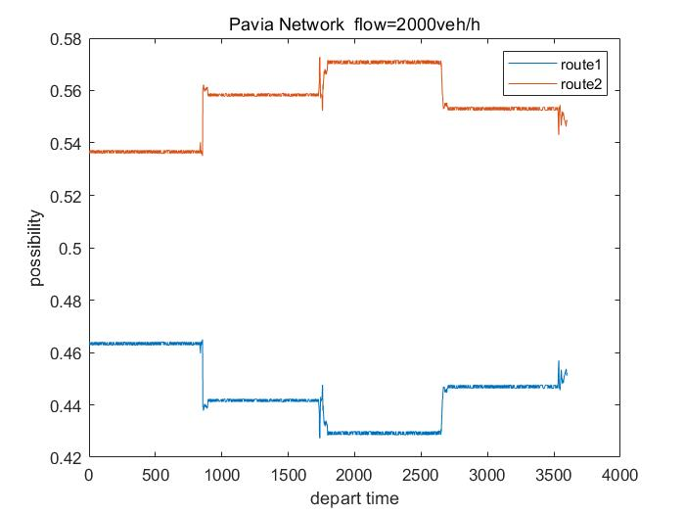
Figure 4-7 The relationship between the probability of selection of route and the departure time of each vehicle in Pavia roundabout network

As can be seen from Figure 4-7, the vehicle in the SUMO simulation updates the route selection based on the average travel cost every 15 minutes. For the vehicles in the simulation, the probability of route 1 stabilizes around 0.44, while the probability of route 2 stabilizes around 0.56, suggesting that the majority of vehicles choose route 2 (Braess route) to enter into the roundabout.

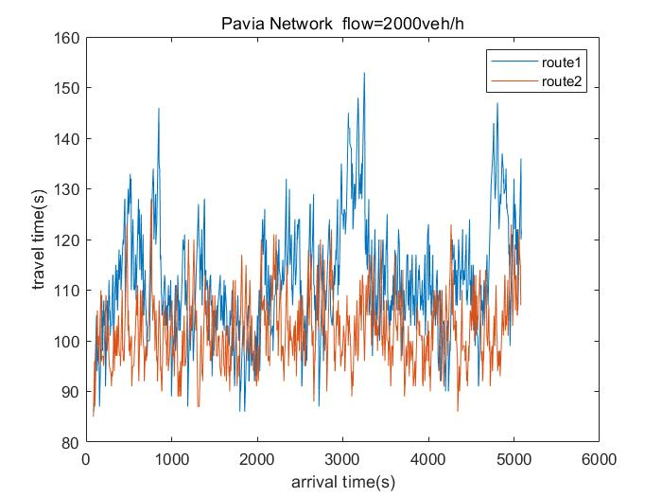
Figure 4-8 The relationship between travel time and arrival time of the vehicle in Pavia roundabout network

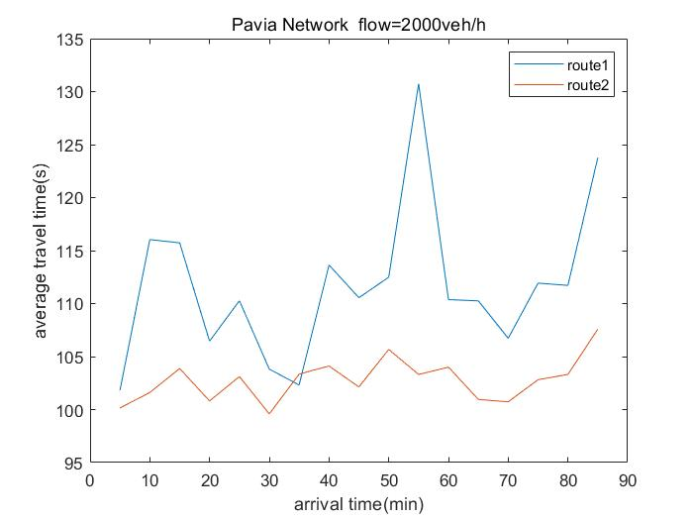
Figure 4-9 The relationship between the average travel time per 5 minutes and arrival time of vehicles in Pavia roundabout network

As can be seen from Figure 4-8 and Figure 4-9, for the Pavia roundabout, the travel time of vehicles choosing route 1 is generally greater than the travel time of vehicles choosing route 2 (Braess route).
Combining the above three pictures, it can be seen that the travel time of vehicles on the Braess route is lower than the travel time of vehicles on the non-Braess route, so the probability of vehicles choosing the Braess route is higher, which eventually leads to the fact that most vehicles choose Braess route, making it difficult to fully exploit the traffic capacity of the roundabout network, which in turn leads to the occurrence of the phenomenon of Braess paradox.

In order to make the simulation closer to the actual situation, this research also studied the phenomenon of Braess paradox of Pavia roundabout network under disturbance. In this research, another two OD pairs in two directions were added in addition to the target OD pair in Pavia roundabout network to disturb the roundabout network and the added OD pairs are shown in Figure 4-10. Between them, the traffic flow added in each direction is 10% of the traffic flow of the target OD pair, and the results are shown in Figure 4-11.

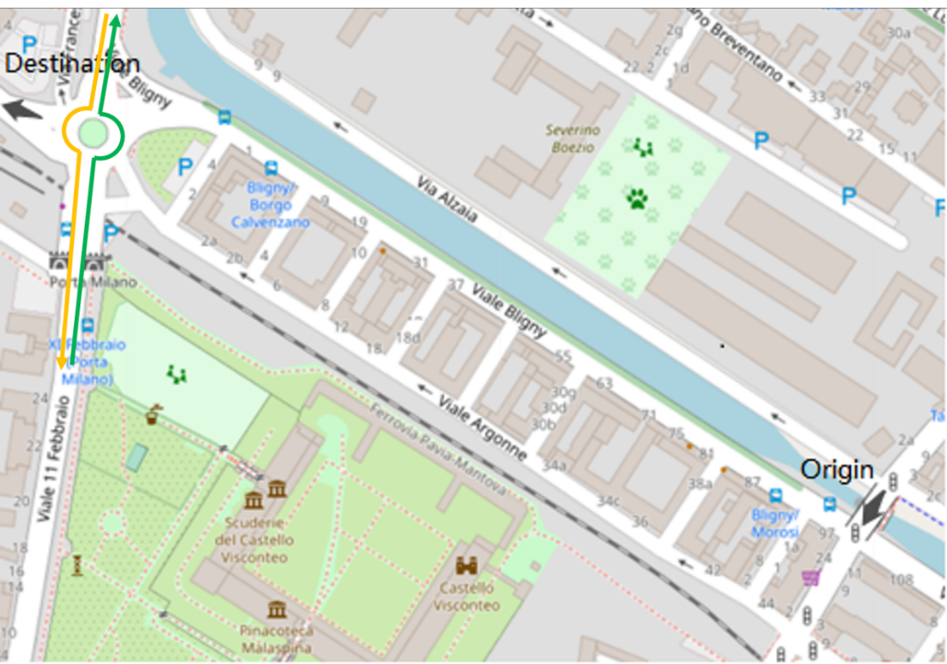
Figure 4-10 Another two OD pairs added to Pavia roundabout network

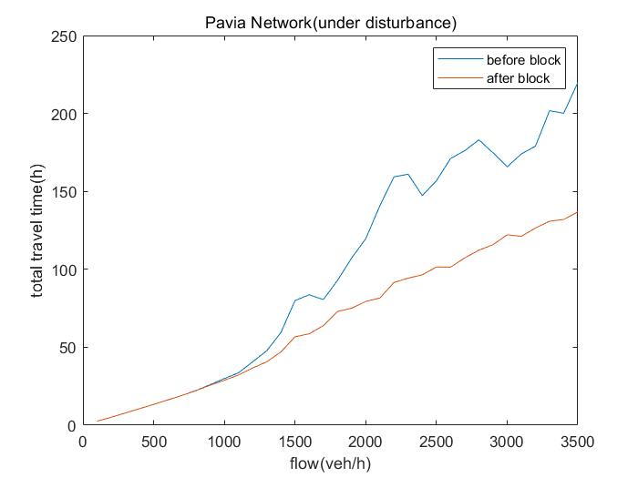
Figure 4-11 The relationship between travel time and traffic flow in Pavia roundabout network before and after blocking some turns (under disturbance)

It can be seen from Figure 4-11 that when the traffic flow is not higher than 800veh/h, the similarity of the two curves is relatively high, indicating that blocking some turns has very little impact on Pavia roundabout network, and it can be considered that the phenomenon of Braess paradox does not occur in Pavia roundabout network. When the traffic flow is higher than 800veh/h, the total travel time of vehicles of the target OD pair after blocking some turns T₂ is smaller than the total travel time of the target OD pair before blocking some turns T₁, which suggests that after adding disturbance, the phenomenon of Braess paradox still occurs clearly in Pavia roundabout network.
By comparing with Pavia roundabout network without disturbance, it can be found that with the added disturbance, the phenomenon of Braess paradox starts to occur at lower traffic flow. Moreover, adding disturbance will make the total travel time of vehicles of the target OD pair of Pavia roundabout network before blocking some turns more volatile, and further aggravate the phenomenon of Braess paradox under high traffic flow.

Solutions

Block some turns

Through the above simulation research, it can be found that blocking some turns can effectively eliminate the phenomenon of Braess paradox caused by the tactical choices of travellers, reduce the traffic time of vehicles in the roundabout network, and effectively improve the traffic efficiency. Therefore, blocking some turns can be one of the effective solutions.

Traffic light control

Although blocking some turns can effectively alleviate the traffic congestion caused by the phenomenon of Braess paradox, in practice, this method will also greatly affect the traffic flow from other directions in the roundabout network. Therefore, traffic lights can be employed instead to guide more vehicles to choose the same path into the roundabout, thereby reducing the impact of the roundabout's own right-of-way rule on vehicles entering into the downstream of the roundabout.
The basic principle of traffic light design in this research is to control the traffic flow leading to the upstream of the roundabout, so as to guide more vehicles to choose the same path to enter into the roundabout. In this simulation research, the cycle time of the traffic light is chosen to be 60 seconds for convenience. At the same time, in order to test the effect of controlling the ratio of the green light time controlling the traffic flow entering into the upstream of the roundabout in the traffic light cycle on alleviating traffic congestion, this research conducted sensitivity analysis on it. For the convenience of the calculation of the green time ratio, the time of traffic light is set in units of 5 seconds in this research. The yellow light time of both phases is set to 5 seconds, the green light time is explored ranging from 5s to 45s in steps of 5s, and the time of the red light is obtained by the method of "red light time = cycle of the traffic light - green light time - yellow light time * 2". In this research, by comparing the total travel time of vehicles of the roundabout network under different green time ratios, a relatively optimal traffic light timing strategy was obtained. In this simulation research of traffic light control, the simulated traffic flow is selected from the traffic flow that can result in the phenomenon of Braess paradox to occur in an equal increment, and the selected traffic flow is set to cover a wide range as much as possible, so as to prove the reliability of traffic light control to alleviate the phenomenon of Braess paradox. It can alleviate the reliability of the phenomenon of Braess paradox. For the simulation of traffic light control, the traffic flow of the simulation for Beijing roundabout network is 2900veh/h, 3100veh/h, 3300veh/h and 3500veh/h, while the traffic flow of the simulation for Pavia roundabout network is 1500veh/h, 2000veh/h, 2500veh/h, 3000veh/h and 3500veh/h.
The simulation research on traffic light control observes the effect of traffic light control on mitigating the phenomenon of Braess paradox by plotting the curves of the relationship between travel time and green time ratio. And the horizontal axis represents the ratio of the green light time controlling the traffic flow entering into the upstream of the roundabout and the vertical axis represents the total travel time of vehicles of the target OD pair in the roundabout network. In addition, this research also plotted the curves of the travel time before and after blocking some turns, and through traffic light control to visually compare and evaluate the effect of different solutions on alleviating the phenomenon of Braess paradox.

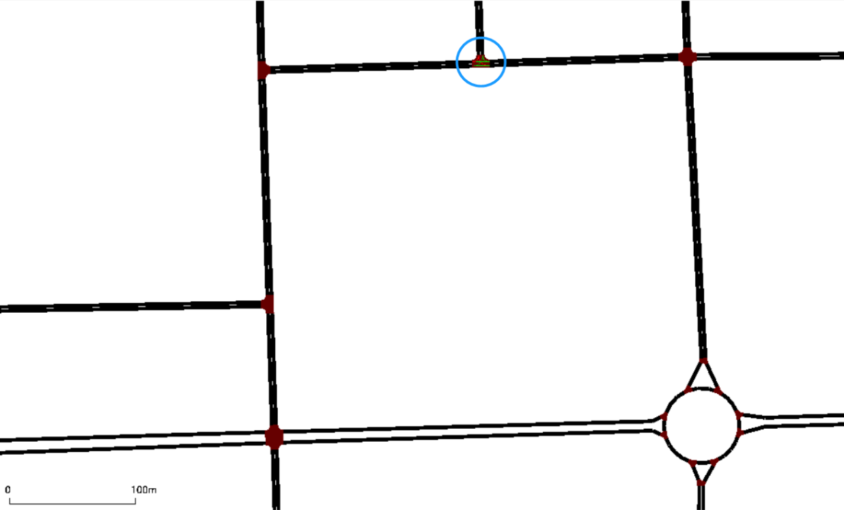
Figure 4-12 The selected location for the design of traffic lights in Beijing roundabout network

As shown in Figure 4-12, in this research, the traffic lights of Beijing roundabout network are designed at the second intersection on the path of the traffic flow leading to the upstream of the roundabout. The reasons are as follows:
1 If set it at the first intersection, the control of the left-turn traffic flow will affect the straight traffic flow and increase the total travel time of vehicles in the roundabout network on account of the reason that there is only one lane in each direction of the road.
2 Setting it at the third intersection will affect traffic from other directions entering the roundabout.
3 Placement at the second intersection also minimizes the impact on traffic in other directions without affecting the traffic flow of traffic from other directions to the roundabout.

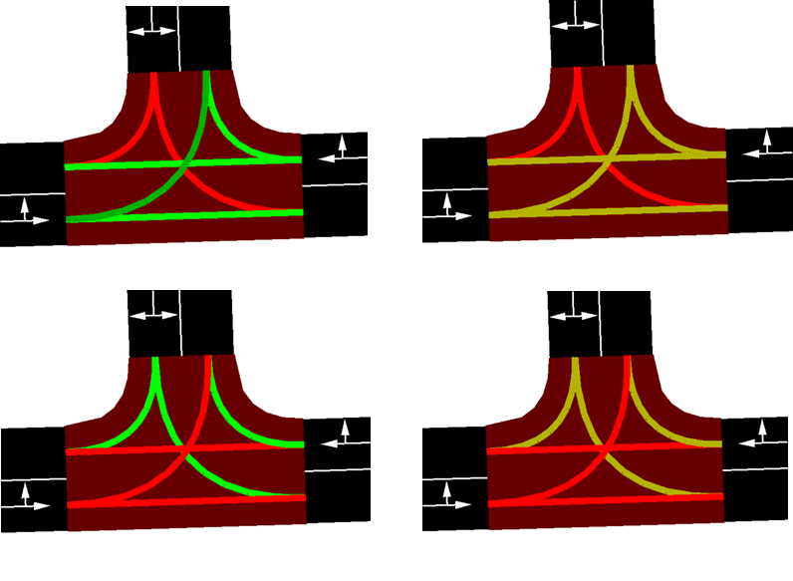
Figure 4-13 Four phases of traffic lights in Beijing roundabout network

As shown in Figure 4-13, the phases of the traffic lights used in Beijing roundabout network are four phases commonly used at T-shaped intersections, that is, to control the traffic flow on the main road and branch road respectively, so as to control the traffic flow entering into the upstream of the roundabout. Among them, the green light phase that controls the traffic flow entering into the upstream of the roundabout is shown as the first phase in Figure 4-13.

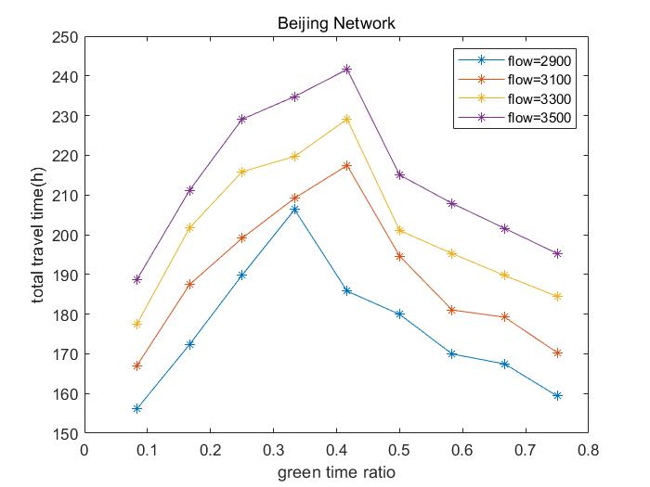
Figure 4-14 The relationship between travel time and green time ratio in Beijing roundabout network

It can be seen from Figure 4-14 that, for Beijing roundabout network, during the cycle time of the traffic lights, the total travel time of vehicles of the target OD pair of the roundabout network will increase first and then decrease with the green time ratio which controls the traffic flow entering into the upstream of the roundabout increasing. The peak value of the total travel time of vehicles of the target OD pair appears when the green time ratio is between 0.3 and 0.45, and the greater the traffic flow, the higher the green time ratio. The lowest value of the total travel time of vehicles of the target OD pair appears when the green time ratio is the smallest (1/12), because when the green time ratio is the smallest, the travel time of vehicles to the upstream of the roundabout reaches the maximum, thus, most vehicles would choose route 1, which greatly alleviates the phenomenon of Braess paradox in the roundabout network and improves the traffic efficiency of the entire network. In the case of high traffic flow, the impact of different green time ratios on the total travel time of vehicles of the target OD in the roundabout network will be quite different.

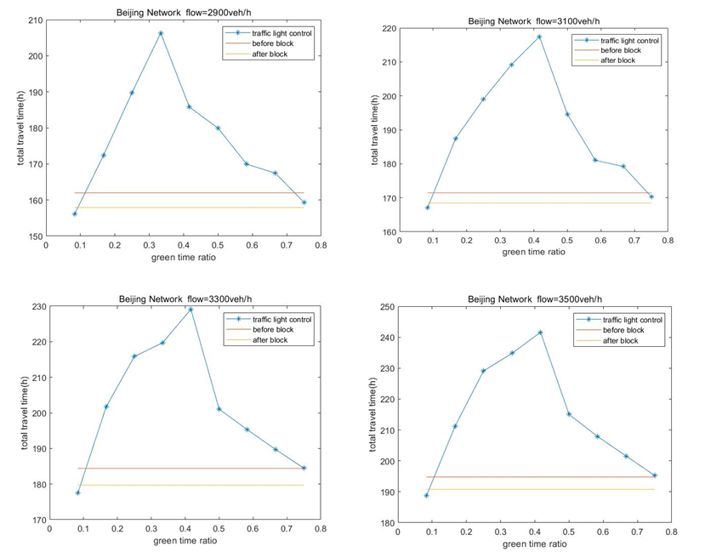
Figure 4-15 Travel time in the case of before and after blocking some turns and through traffic light control in Beijing roundabout network

It can be seen from Figure 4-15 that for Beijing roundabout network, the effect of blocking some turns is generally better than using traffic lights to improve the traffic efficiency of the roundabout network. When the green time ratio is not less than 1/6, the total travel time of vehicles of the target OD pair obtained through traffic light control T₃ is greater than the total travel time of vehicles of the target OD pair before blocking some turns T₁, so traffic light control cannot alleviate the phenomenon of Braess paradox in this case. On the contrary, it would increase the congestion of the roundabout network. When the green time ratio is not higher than 1/12, the total travel time of vehicles of the target OD pair obtained through traffic light control T₃ is less than the total travel time of vehicles of the target OD pair after blocking some turns T₂, that is, the effect of traffic light control is better.

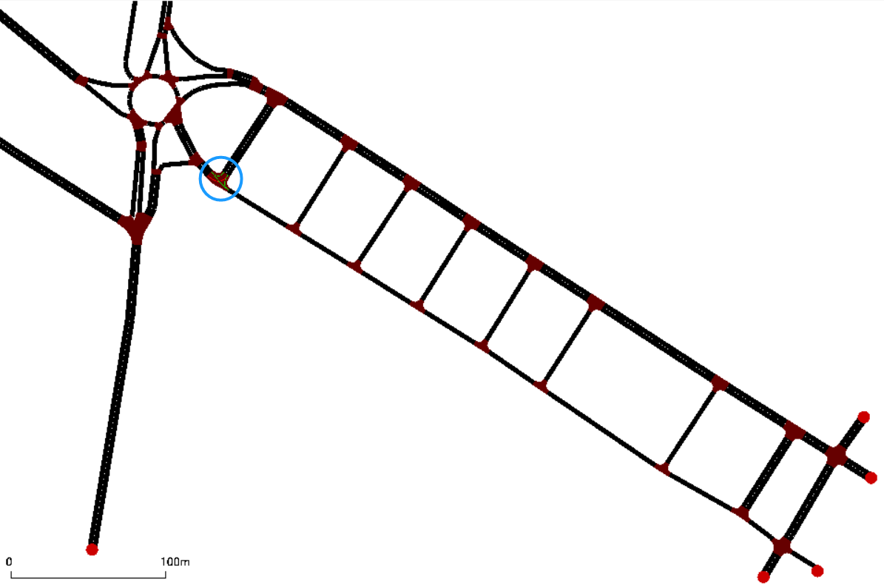
Figure 4-16 The selected location for the design of traffic lights in Pavia roundabout network

As shown in Figure 4-16, this research designed the traffic lights at the intersection before entering the roundabout in the Pavia roundabout network, because this can control the traffic flow in the all paths from the origin to the upstream of entering into the roundabout.

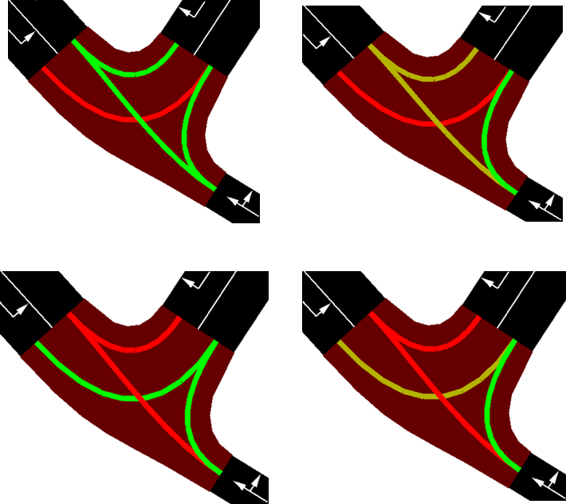
Figure 4-17 Four phases of traffic lights in Pavia roundabout network

As shown in Figure 4-17, the phases of the traffic light used in this research in Pavia roundabout network control the traffic flow in the direction of entering into the upstream of the roundabout and the traffic flow in other directions, respectively, and the right-turn green light on route 2 is always open with the purpose of enabling some vehicles that have chosen route 2 to enter into the upstream of the roundabout to change to use route 1 after encountering the traffic light (but this simulation research found that most vehicles would choose route 1 due to the setting of the traffic light, so fewer vehicles on the road choose route 2. In the simulation, there is not a situation where the vehicles on route 2 turn to enter route 1 through the branch roads due to the fact that the traffic lights lead to longer wait time, that is, the right-turn green light on route 2 does not affect the route selection of vehicles on route 2, so the right-turn green light on route 2 does not have an impact on alleviating the phenomenon of Braess paradox in the Pavia roundabout network. However, in practice, in order to improve the convenience of traffic flow in other directions, it is still better to keep right-turn green light on the Braess route open during the whole cycle time). Among them, the green light phase controlling the traffic flow entering into the upstream of the roundabout is shown as the first phase in Figure 4-17.

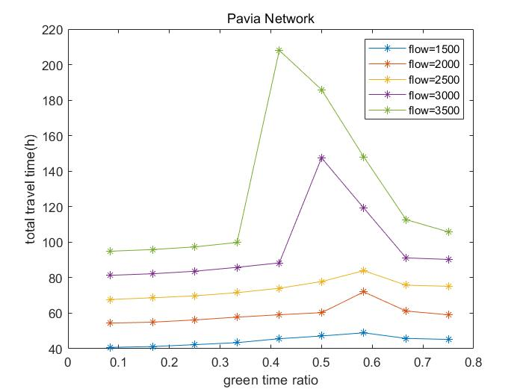
Figure 4-18 The relationship between travel time and green time ratio in Pavia roundabout network

It can be seen from Figure 4-18 that for Pavia roundabout network, during the cycle time of the traffic light, the total travel time of vehicles of the target OD pair in the roundabout network would increase first and then decrease when the ratio of the green light time controlling the traffic flow into the upstream of the roundabout increases. The peak value of the total travel time of vehicles of the target OD pair appears when the green time ratio is between 0.4 and 0.6, and the greater the traffic flow, the peak will appear at the lower green time ratio. The lowest value of the total travel time of vehicles of the target OD pair appears when the green time ratio is the smallest (1/12), which is also because the vehicle travel time to the upstream route of the roundabout reaches the maximum when the green time ratio is the smallest. Therefore, most vehicles would choose route 1, which greatly alleviates the phenomenon of Braess paradox in the roundabout network and improves the traffic efficiency of the entire network. In the case of high traffic flow, the impact of different green time ratios on the total travel time of vehicles of the target OD pair in the roundabout network is quite different.
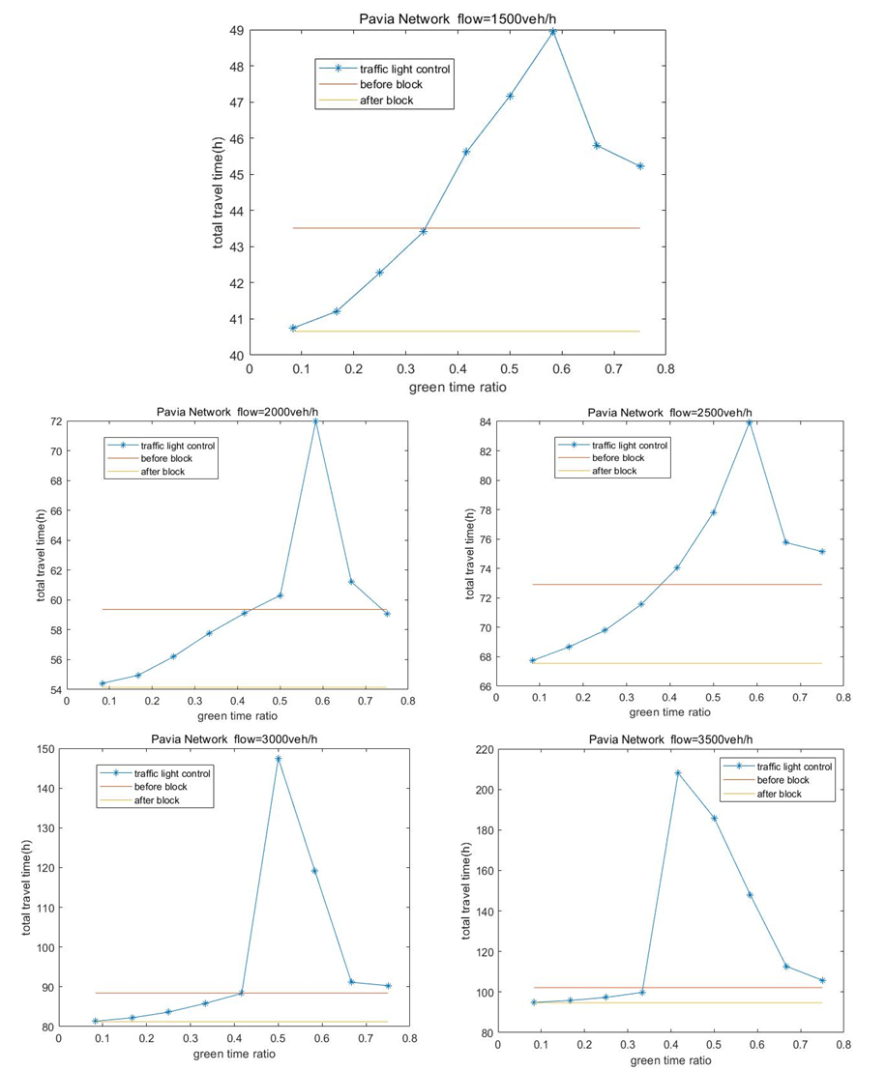
Figure 4-19 Travel time in the case of before and after blocking some turns and through traffic light control in Pavia roundabout network

It can be seen from Figure 4-19 that for Pavia roundabout network, blocking some turns is also generally better than using traffic lights to improve the traffic efficiency of the roundabout network. When the green time ratio is not less than 5/12, the total travel time of vehicles of the target OD pair obtained through traffic light control T₃ is greater than the total travel time of vehicles of the target OD pair before blocking some turns T₁, and traffic light control cannot alleviate the phenomenon of Braess paradox. However, when the green time ratio is not higher than 1/3, the total travel time of vehicles of the target OD pair obtained through traffic light control T₃ is less than the total travel time of vehicles of the target OD pair before blocking some turns T₁, but greater than the total travel time of vehicles of the target OD pair after blocking some turns T₂, indicating that the use of traffic lights can alleviate the phenomenon of Braess paradox, but for Pavia roundabout network, its effect is not as good as blocking some turns.

In addition, this research also conducts simulation research of traffic light control for Pavia roundabout network under disturbance, as shown in Figure 4-20.

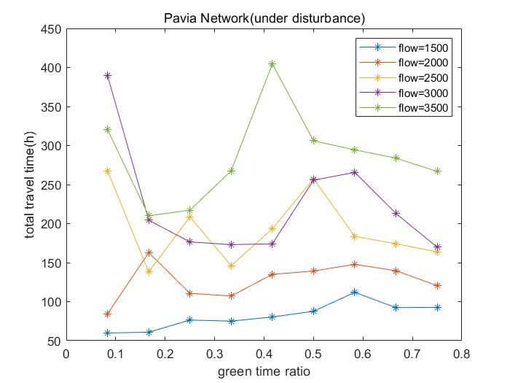
Figure 4-20 The relationship between travel time and green time ratio in Pavia roundabout network (under disturbance)
It can be seen from Figure 4-20 that for Pavia roundabout network, in the case of Pavia roundabout network under disturbance, during the cycle time of the traffic light, the total travel time of vehicles of the target OD pair in the roundabout network no longer shows a trend of increasing first and then decreasing when the ratio of the green light time controlling the traffic flow entering into the upstream of the roundabout increases, and the peak value of the total travel time of vehicles of the target OD pair is irregular. When the traffic flow is not higher than 2000veh/h, the lowest value of the total travel time of vehicles of the target OD pair appears when the green time ratio is the smallest (1/12). But when the traffic flow is higher than 2000veh/h, the minimum value of the total travel time of vehicles of the target OD pair also appears irregularly. In the case of high traffic flow, the impact of different green time ratios on the total travel time of vehicles of the target OD pair in the roundabout network is quite different.
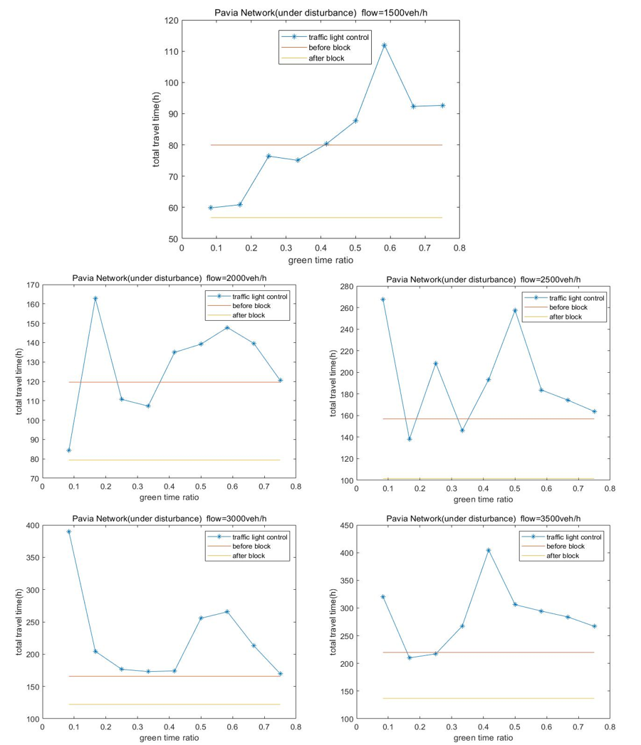
Figure 4-21 Travel time in the case of before and after blocking some turns and through traffic light control in Pavia roundabout network (under disturbance)

It can be seen from Figure 4-21 that for Pavia roundabout network, in the case of Pavia roundabout network under disturbance, blocking some turns is totally better than using traffic lights to improve the traffic efficiency of the roundabout network. When the green time ratio is not less than 5/12, the total travel time of vehicles of the target OD pair obtained through traffic light control T₃ is greater than the total travel time of vehicles of the target OD pair before blocking some turns T₁, and traffic light control cannot alleviate Braess paradox. However, when the green light time ratio is not higher than 1/3, the total travel time of vehicles of the target OD pair obtained through traffic light control T₃ is less than the total travel time of vehicles of the target OD pair before blocking some turns T₁, but greater than the total travel time of vehicles of the target OD pair after blocking some turns, the use of traffic lights can alleviate the phenomenon of Braess paradox, but for Pavia roundabout network, its effect is not as good as blocking some turns.

Conclusions

This research found that in the case of very low traffic flow, the roundabout network is not congested, so the phenomenon of Braess paradox does not occur. Braess paradox occurs when the traffic flow rises to a certain level of congestion in the roundabout network, and it continues to intensify with the increase in traffic flow. And blocking some turns and setting up traffic lights to guide most vehicles to choose the same route to enter into the roundabout are two effective ways to alleviate the congestion caused by the phenomenon of Braess paradox in the roundabout network. From the perspective of the mitigation effect, the method of blocking some turns is generally better than the method of traffic lights to control the traffic flow, but blocking some turns is difficult to take into account the traffic flow in other directions in the roundabout network. Therefore, in terms of convenience, the method of blocking some turns is not as good as the way of using traffic lights to control traffic flow.
In addition, this research found that in a roundabout network with multiple branch roads connecting main paths leading to the upstream and downstream of the roundabout, the traffic rule at the intersection of the branch road and the main path (whether vehicles are allowed to enter into the intersection when the road ahead is congested) can have a large impact on the simulation results, and the size of the roundabout network may cause some variance in the simulation results. Therefore, when simulating Braess paradox of the roundabout, special attention should be paid to the topology, traffic rules and the scale of the roundabout network.
There are still shortcomings in this research. When using traffic lights to alleviate the phenomenon of Braess paradox in the roundabout network, there is no more in-depth analysis and setting for the selection of traffic light cycles. Advanced signal timing software can be used to optimize the timing, so as to better play the role of traffic lights in alleviating the traffic congestion caused by the phenomenon of Braess paradox.
Besides, when simulating the phenomenon of Braess paradox in the roundabout network, this research found that the speed limits of the roads have a great influence on the occurrence of the phenomenon of Braess paradox. The research can further explore the speed limits of the roads in the roundabout network, such as studying how they affect the phenomenon of Braess paradox by means of sensitivity analysis or differentiating the speed limits of different paths.

References

- Braess D. Über ein Paradoxon aus der Verkehrsplanung[J]. Unternehmensforschung, 1968, 12(1): 258-268.
- Sun L, Ling X M, Tan Q, et al. Combination positioning and analysis of inefficient road sections in urban large-scale transportation network [J]. Journal of Railway Science and Engineering, 2016, 13(7): 1414-1419.
- Eric I. Pas, Shari L. Principio. Braess' paradox: Some new insights[J]. Transportation Research Part B,1997,31(3):
- Steinberg R, Zangwill W I. The prevalence of Braess' paradox[J]. Transportation Science, 1983, 17(3): 301-318.
- Bazzan A L C, Klügl F. Case studied on Braess paradox: simulating route recommendation and learning in abstract and microscopic models[J]. Transportation Research Part C: Emerging Technologies, 2005, 13(4): 299-319.
- Roughgarden T. On the severity of Braess Paradox: Designing networks for selfish users is hard[J]. Journal of Computer and System Sciences, 2006, 72 (5): 922-953.
- Youn H, Gastner M T, Jeong H. Price of anarchy in transportation networks: efficiency and optimality control[J]. Physical review letters, 2008, 101(12): 128701.
- Bagloee S A, Ceder A, Tavana M, et al. A heuristic methodology to tackle Braess paradox detecting problem tailored for real road networks[J]. Transportmetrica A: Transport Science, 2014, 10 (5) : 437－456.
- Sun L, Liu L K, Xu Z Z, et al. Locating inefficient links in a large-scale transport network [J]. Physica A: Statistical Mechanics and its Applications, 2015(419): 537-545.
- Hwang M C, Cho H J. The classical Braess paradox problem revisited: a generalized inverse method on non-unique path flow cases[J]. Networks and Spatial Economics, 2016, 16(2): 605-622.
- Kolata, G., 1990. What if They Closed 42d Street and Nobody Noticed? The New York Times, December 25.
- Vidal, J., 2006. Heart and Soul of the City. The Guardian, November 1.
- Grynbaum M M. Broadway is Busy, with Pedestrians, if Not Car Traffic[J]. The New York Times, 2010.
- Troutbeck R J, Kako S. Limited priority merge at unsignalized intersections[J]. Transportation Research Part A: Policy and Practice, 1999, 33(3-4): 291-304.
- Tanyel S, Yayla N. A discussion on the parameters of Cowan M3 distribution for Turkey[J]. Transportation Research Part A: Policy and Practice, 2003, 37(2): 129-143.
- Ren F T, Yang F, Rong J, Zhang Z Y. Analysis of the traffic capacity of the roundabout in Beijing [J]. Highway Traffic Science and Technology, 2001(03):64-66+74.
- Pollatschek M A, Polus A, Livneh M. A decision model for gap acceptance and capacity at intersections[J]. Transportation Research Part B: Methodological, 2002, 36(7): 649-663.
- Zhang J, Ma J, Liu M. Research on traffic capacity of urban road roundabout based on mathematical statistics method [J]. Journal of Beihua University (Natural Science Edition), 2003(06):541-543.
- Jin S Q, Li J, Du P F. Research on the application of simulation technology to the traffic capacity of roundabouts [J]. Highway Traffic Science and Technology, 2004(02):95-98.
- Yap Y H, Gibson H M, Waterson B J. An international review of roundabout capacity modelling[J]. Transport Reviews, 2013, 33(5): 593-616.
- Chen R. Microscopic Simulation and Evaluation of the Roundabout Capacity Model in Highway Capacity Manual[D]. University of Minnesota, 2018.
- Burov M, Kizilkale C, Kurzhanskiy A, et al. Detecting Braess Routes: an Algorithm Accounting for Queuing Delays With an Extended Graph[C]//2021 IEEE International Intelligent Transportation Systems Conference (ITSC). IEEE, 2021: 2125 -2130.
- Bo C Y, Cui H L, Wang W, Xiang Q J. Research on service capacity of roundabouts [J]. Journal of Huazhong University of Science and Technology (Natural Science Edition), 2002(05):47-49.DOI:10.13245/j. hust.2002.05.016.
- Arndt O, Troutbeck R J. Relationship between roundabout geometry and accident rates[J]. Transportation research circular, 1998 (E-C003): 28: 1-16.
- Bared J, Edara P K. Simulated capacity of roundabouts and impact of roundabout within a progressed signalized road[C]//National Roundabout Conference: 2005 Proceedings. Transportation Research Board of the National Academies, Vail, USA. 2005.
- Vaiana R, Gallelli V, Capiluppi G F. Roundabout intersections: analysis for scenarios by micro-simulation[C]//Proceedings of 4th International SIIV Congress-Advances in transport infrastructures and stakeholder expectations. 2007.
- Yin D, Qiu T Z. Comparison of macroscopic and microscopic simulation models in modern roundabout analysis[J]. Transportation research record, 2011, 2265(1): 244-252.
- Zhao Hailong et al. Comparative research on traffic capacity of roundabout and cross-shaped intersection based on VISSiM signal control environment [J]. Shandong Transportation Science and Technology. 2012, 06: 65-67.
- Arroju R, Gaddam H K, Vanumu LD, et al. Comparative evaluation of roundabout capacities under heterogeneous traffic conditions[J]. Journal of Modern Transportation, 2015, 23(4): 310-324.
- Małecki K, Wątróbski J. Cellular automaton to study the impact of changes in traffic rules in a roundabout: a preliminary approach[J]. Applied Sciences, 2017, 7(7): 742.
- Gallelli V, Vaiana R. Safety improvements by converting a standard roundabout with unbalanced flow distribution into an egg turbo roundabout: Simulation approach to a case study[J]. Sustainability, 2019, 11(2): 466.
- Owais M, Abulwafa O, Abbas Y A. When to decide to convert a roundabout to a signalized intersection: simulation approach for case studied in Jeddah and Al-Madinah [J]. Arabian Journal for Science and Engineering, 2020, 45 (10): 7897-7914.

